# PROJECT DESIGN PHASE II TECHNOLOGY STACK (ARCHITECTURE AND STACK)

|  |  |
| --- | --- |
| **TEAM ID** | PNT2022TMID14121 |
| **PROJECT NAME** | Inventory Management System for Retailers |
| **MAXIMUM MARKS** | 4 MARKS |

**TECHNICAL ARCHITECTURE:**

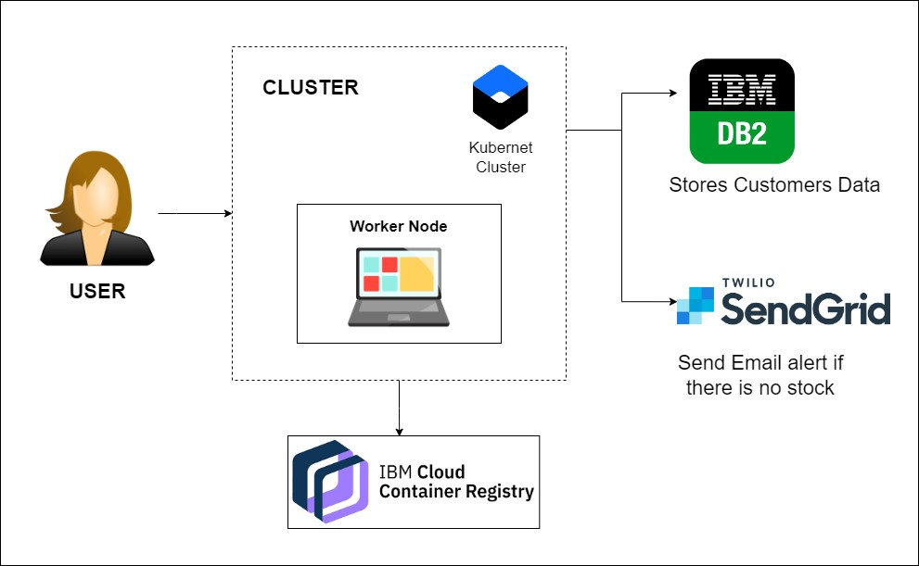

# Table 1: Components & Technologies:

|  |  |  |  |
| --- | --- | --- | --- |
| **S.NO** | **COMPONENT** | **DESCRIPTION** | **TECHNOLOGY** |
| 1. | User Interface | Information processed will be sent to the user as a mail through web application | HTML, CSS, JQuery, JS,  Python, etc. |
| 2. | Application Logic-1 | User registration through form and confirmation will be sent to the user via email. | Flask, SendGrid |
| 3. | Application Logic-2 | Dashboard is used to track the sales of product and inventory levels. | Flask |
| 4. | Application Logic-3 | User will get notified about the real time stock status | Flask |
| 5. | Database | The data can be stored in a database and the user can retrieve or manipulate the data anytime | IBM DB2. |
| 6. | Cloud Database | Information of the stocks will be stored and hosted on the cloud | IBM DB2. |
| 7. | File Storage | Requirements to store files | IBM Block Storage or Other Storage Service or Local File system |
| 8. | External API-1 | SendGrid used in application will send the email alert if there is less number or no stock to the user in real time | SendGrid |
| 9. | External API-2 | IBM container Registry enables you to store and distribute Docker images in a managed private registry | IBM container registry |
| 10. | Infrastructure (Server/Cloud) | Application Deployment on Local System / CloudLocal Server Configuration:localhost:5001(Flask) Cloud Server Configuration : Kubernetes | Local, Cloud Foundry, Kubernetes, etc. |

**Table-2: Application Characteristics:**

|  |  |  |  |
| --- | --- | --- | --- |
| **S.NO** | **CHARACTERISTICS** | **DESCRIPTION** | **TECHNOLOGY** |
| 1. | Open-Source Frameworks | SendGrid will send email alerts, if there is less stock to the user, Kubernetes for manipulating Kubernetes API objects, IBM DB2 is used for storing and retrieving the data efficiently. | Flask, SendGrid, IBMDB2,  Kubernetes |
| 2. | Security Implementations | We use login for the user and the information will be hashed so that it will be very secure to use. | IBM container registry |
| 3. | Scalable Architecture | It is scalable that we are going to use data in kb so that the quiet amount of storage is satisfied. | Flask |
| 4. | Availability | Prediction will be available for every user but only for premium user news, database and price alert will be alert | Flask |
| 5. | Performance | It will perform fast and secure even at the lower bandwidth | Flask, IBM container registry, IBM DB2. |

# REFERENCES:

<https://c4model.com/> <https://www.ibm.com/cloud/architecture>

<https://developer.ibm.com/patterns/online-order-processing-system-during-pandemic/> <https://aws.amazon.com/architecture>